Welcome to our weekly newsletter for
Good News for Friday 07 July 2023

Dear Sisters and Brothers in Christ,
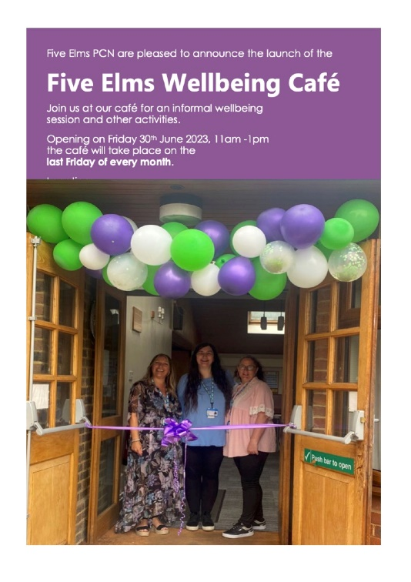
Last Sunday at our Café service we thought about our 'Community Engagement' as a church. In particular we considered whether what we already do in and for our community is what is actually needed. We also thought about what our values are (welcoming and friendly seemed to be themes) and we identified some of our individual gifts. So, a good question to ask is: are we using our gifts to reach out to our neighbours AND to fulfil our mission statement?... Which is:

- To offer everyone in our Parish opportunities to hear, experience and respond to the call of Jesus Christ
- To plan and deliver initiatives that will grow our church...
It might be worth us thinking about how we can take our friendly and welcoming values further and actually share the fantastic news of Jesus Christ to those we meet who have not yet ‘heard his call.’
On Friday 30th June the Five Elms Wellbeing Café was launched in the St Augustine’s Church rooms. Whilst this is not ‘our’ initiative this is a wonderful opportunity for us to connect with many more people in our locality who will be attending on the last Friday of every month. There are many parallels with our “Welcome Space” (offering friendship, hot drinks and cake, sharing life and enjoying guest speakers). At the Wellbeing Café there will also be an ‘all-levels’ exercise class, some access to health professionals and a sharing of ideas about how we can help each other to thrive.
Jesus said that the second most important commandment is to ‘Love your neighbour as yourself’... The Wellbeing Café is going to be a wonderful chance to find out who are neighbours actually are!

Prayer

Lord, you have said that to truly love you
then I must also love my neighbour.
Teach us as a church to seek out the lost
and to love them as you have loved us,
that this world might be
a better neighbourhood
in which to live and share,
through Jesus Christ our Lord. Amen.

God Bless you
Revd Steve Spencer & Revd Rachel Winn

This Week Services
5th Sunday after Trinity 9th July
St Augustine's Church: Southborough Lane, Bickley, BR2 8AT.
10.00am ~ ‘Generosity Sunday’ with Holy Communion... and guest speaker Liz Mullins, Diocesan Generous Giving Advisor
If you are unable to come this service will be Live-Streamed on our YouTube channel address:
https://youtube.com/channel/UCR70BiHHimXOLZpMSXV44IQ

Scripture Reading:

First Reading: Romans 7: 15-25a
Gospel Reading: Matthew 11: 16-19, 25-end

Collect – Special Prayer for Today

Almighty God,
send down upon your Church
the riches of your Spirit,
and kindle in all who minister the gospel
your countless gifts of grace;
through Jesus Christ our Lord.

Next Week’s Services
6th Sunday after Trinity 16th July
St Augustine's Church Southborough Lane, Bickley, BR2 8AT.
10.00am ~ Morning Worship with Baptism

And an Evening Service
At St Luke’s Church, Bromley Common, BR2 9RN
5.30pm - Holy Communion

PARISH NEWS AND NOTICES

News from Helen Baker: For those of you not aware Helen Baker is moving to pastures new. She will be heading down to the English Riviera to take up a position of Learning Support Assistant at a school for children and young people with Special Education Needs and Autism. Please join us for her last service on Sunday 13th August and stay for a bring and share lunch afterwards. We wish Helen all the best for her next adventure in life.
July Diary
Why not click on the link to download this and join us where you can. Find the July Diary here.

What is on this Week

On the Green Pre-Loved Sale:
Saturday 8th July 12.00 noon ~ 2.00pm
‘Hunt 4 A Bargain’
(St Augustine’s church, Southborough Lane, BR2 8AT)

You are warmly invited to join us on the sunny St Augustine’s Church Green to help us raise funds for the church. There will be a large variety of new and nearly new (pre-loved) items for all the family, young and mature years!

Youth Connect - Get Cooking
Saturday 8th July – 7.00-9.00pm
Meeting in the Barnard room, at St Augustine’s Church.

The ARK Toddler Group
Wednesday 12th July from 10.00am
The Ark runs every Wednesday (term time only) at St Augustine's Church. Please use the link below for Eventbrite each week, one ticket per child, tickets on a first come first served basis. If anyone is available to help us set up for our ARK session on Tuesday afternoons at 5pm, please let Helen know.
https://www.eventbrite.co.uk/o/st-augustines-with-st-lukes-church-35212875693

Midweek Holy Communion
Wednesday 12th July at 12 Noon
Midweek Holy Communion in St Augustine's Church will take place every second and fourth Wednesday of the month. This is held in the Chapel, and all are welcome.

Ice Pops on the Green
Wednesday 12th July from 3pm
Free Ice Pops to passers-by, (weather dependent).

Mother’s Union Wave of Prayer
Thursday 13 July at 12:00noon
This is taking part in St Augustine’s Chapel. Please join us to pray for our link dioceses.

WELCOME SPACE ~ come and enjoy coffee / lunch & friendship, all welcome: -
Every Thursday, from 11.00am - 4.00pm

Dates For Your Diary
Merry Pilgrims Walk
Friday 14th July at 10.30am
Join us for a gentle stroll on flat paths. Suitable for frames, wheelchairs and buggies. All are welcome. Meeting Tent Peg Lane off Crestwood Drive. The carpark is open and free to use. Bring a picnic lunch.

Friends Re-Unite, for Food, Chat & Fun
Monday, 17th July, 2023
We meet in the Garden Room at 12.30 pm for a couple of hours.
We'll be delighted if your friends join us. We bring our own lunch,(sandwiches, etc.), coffee, tea, and biscuits are provided.
A small donation towards the upkeep of the Church Rooms would be appreciated. No need to phone, but Sally's no. is 020 8466 6005

Forget me not Café
Tuesday 18th July at 1.30pm
This a memory café for anyone with dementia, their families, carers and friends, run by members of the Bromley Common group of churches. For anyone who is needing support because of personal experience or concern about friends or family with dementia and especially for those suffering from dementia and their carers. You are welcome to come along for tea, coffee and cakes available plus a time to relax with a singsong too.
We meet on the third Tuesday of every month at 1.30 pm in the Garden Room.

Mothers’ Union Bring and Share lunch
Wednesday 19 July at 12:30pm
The lunch is in aid of The Mothers’ Union Summer of Hope, supporting MU projects in Great Britain and Ireland. All welcome – bring some lunch to share.

Youth Connect ~ dates for Summer Term:
22nd July ~ Outdoor Fun (games and barbeque)
‘5 to the Bar’ is back!
Saturday 22nd July at 7pm
Phil Emery’s jazz group, 5 to the Bar, is back performing and is playing at the Sports Club in Farnborough Village in aid of the RNLI. Enjoy an evening of jazz and support a good cause, too!

Parish Weekend away ~Ashburnham Place
Friday 5th - Sunday 7th January 2024
We have not had a Parish Weekend away for some years. This post pandemic period gives us an ideal opportunity to look afresh at what God may be calling us to do in our parish and enable us to develop a plan together for the next 3-5 years.

Further details including cost available soon. Please do not let the cost become a barrier www.ashburnham.org.uk.

Charity and Community Updates
BROMLEY FOOD BANK ~ do not forget us!

The Food Bank has plenty of pasta, cereal, biscuits, spiced figs and tea.

PLEASE MAKE SURE ALL FOOD IS IN DATE BEFORE YOU DONATED IT AND DO NOT DONATE ANY CHILLED OR FROZEN ITEMS AS THEY DO NOT HAVE THE CORRECT STORAGE FOR IT.

Keep in touch
Though we are not all able to meet in person, we certainly do not want anyone to feel isolated or alone. If you know anyone who might appreciate a call, do let us know by contacting the Vicar or emailing the Office.
We also have a prayer team, and you can send in prayer requests for yourself or others.
Lastly, if you know of someone who would like to receive our weekly newsletter, then forward this email to them and ask them to sign up here.

Love, prayers and the peace of the Lord Jesus be with you always.

Contact Details
Vicar Rev Steve Spence
07778784331 revsteve.spencer@btinternet.com
Curate Rev Rachel Winn
07311 330202 curaterachel@yahoo.com
Youth & Schools Minister Helen Baker
07576 233119 hbyouthpasty@hotmail.co.uk
Church Warden Hilary Chittock 07884 195700
Church Warden Jeff Blyth 07557 349279
Parish Office 020 8295 1550 office@st-augustines.org.uk
The parish office is open every weekday morning
between 10am – 1pm
Victoria Bouwer Mon, Weds & Fri
Linda Spencer Tues & Thurs
Hall Bookings
St Luke’s bookings@st-augustines.org.uk
St Augustine’s liz@emailcarter.plus.com

Online Donations to St Augustine’s with St Luke’s
There are several ways to donate,
You can donate online to our bank details are 20-14-33 20772100.
Payee Account Name
THE PCC OF THE ECCLESIASTICAL PARISH OF ST AUGUSTINES WITH ST LUKES BROMLEY
Alternatively, you can give via credit or debit card on our Online Web Page
Or use the below QR Code – under the Gift Aid for donations only up to £30
St Augustine's with St Luke's Parish Church is a Registered Charity
(Charity Number 1129375)

