The Parish of St Augustine's with St Luke's
Sharing God's Love
The Parish of St Augustine’s with St Luke’s
Sharing God’s Love

Welcome to our weekly newsletter for
Good News for Friday 31st March 2023
Dear Sisters and Brothers in Christ,
Over the last six weeks many of us have been attending the Lent Sessions, either in person or online. We have been thinking about some of the 'Holy Habits' that Jesus's disciples were called to have ~ and asking whether we, as his followers today, demonstrate these too. When Jesus calls us to 'follow him' what does this actually look like on a practical level? How does this affect our daily lives? If there was only one thing which inspired or challenged you during this period of Lent, please invite God's transforming Spirit to work in a new way and let Christ change your heart.
As we enter Holy Week we start this Sunday with Palm Sunday at our Café Church; come along and expect to encounter Jesus! The week then unfolds with Evening Prayer, an opportunity for an Easter Meditation, a Maundy Thursday service with foot washing and a thought provoking three hours of 'Reflection at the Cross' on Good Friday, which you can dip in and out of. The solemnity of the week is meant to challenge and sadden us but, thanks to Jesus Christ, the joy of Easter awaits us soon after.
Prayer
Almighty Father,
who sent your only Son Jesus Christ to save us from our sin;
as one of your disciples show me how I can honour you and
bring glory to your name, by walking in the way of Jesus.
Give me grace and mercy as I try and fail,
guidance when I'm not sure which way to go,
and wisdom to trust you in all things,
In Jesus' name, Amen.
God Bless you
Revd Steve Spencer & Revd Rachel Winn
This Week Services ~ Holy Week
St Augustine's Church: Southborough Lane, Bickley, Bromley BR2 8AT.
Palm Sunday 2nd April ~ Café Church 10.00am
If you are unable to come this service will be Live-Streamed on our YouTube channel address:
https://youtube.com/channel/UCR70BiHHimXOLZpMSXV44IQ
Monday 3rd April ~ Evening Prayer 7.00pm
Wednesday 5th April ~ Faces of Easter Meditation 7.00pm
Maundy Thursday 6th April ~ Holy Communion and Foot Washing
7.00pm
Good Friday 7th April ~ Reflections at the Cross
12.00 Noon - 3.00pm
Collect
True and Humble king,
hailed by the crowd as Messiah:
grant us the faith to know you and love you,
that we may be found beside you
on the way of the cross,
which is the path of glory. Amen
Scripture Readings:
First Bible Reading: Philippians 2: 5-11
Second Bible Reading: Matthew 21: 1-11

Next Week Services – Easter Week
St Augustine's Church Southborough Lane, Bickley, Bromley BR2 8AT.
Easter Sunday 8th April ~ Dawn Service ~ 6.00am
~ Holy Communion ~ 10.00am
Next St Luke’s Services
Sunday 16th April~ Second Sunday of Easter:
Holy Communion ~ 5.30pm
PARISH NEWS AND NOTICES
Share the Joy of Easter
We do have a wonderful selection of covers for Easter eggs and labels at the back of the church but if you have knitted some and not added them to the collection then please do so as soon as possible. This year we are offering them to groups of children who are connected in some way with St Augustine’s with St Luke’s and some adult groups who meet on our premises. We really would like to encourage anyone reading this to Share the Joy of Easter in this way with neighbours and those around them of any age, friends and family members. Please take as many covers as you feel able to distribute.

Save the date - Coronation on the Green
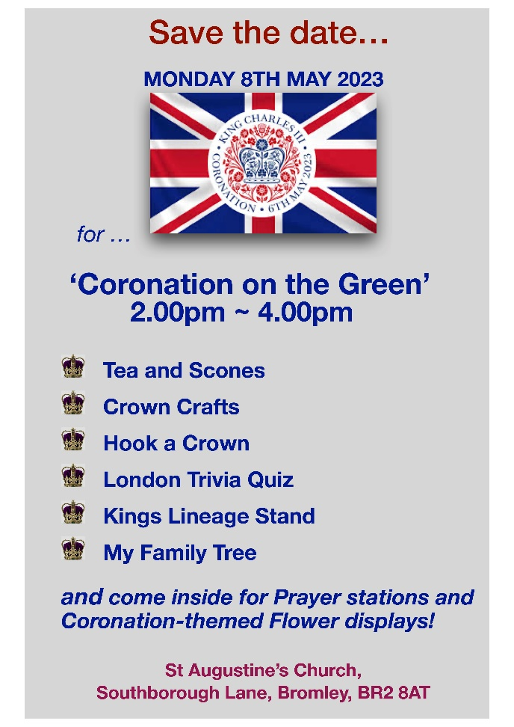
Electoral Roll
The Church electoral roll contains the names and addresses of everyone who can vote at the Annual Parochial Church Meeting (APCM). If you are not presently on the church Electoral Roll and think you might like to be, there are forms at the back of the Church. Alternatively please speak to the church office staff or Steve, Rachel or Hilary to obtain a form to fill in.

Children's Society Boxes
A big thank you to everyone who donated with cash and cheques.
This year we raised a grand total of £573.22p.
With many thanks again. Valerie Gorman
Diary:
Why not click on the link to download this and join us where you can. Find the April Diary here.
What is on this Week
There will be no ARK Toddler Group for the next two weeks as is the School holidays.
WARM WELCOME SPACE and CAMEO
Thursday 6th April ~ from 10.30am until 4.00pm
Our Warm Welcome Space is for anyone who needs to keep warm during the energy crisis. Why not come along and meet new friends, work in a quiet space or just sit and read the newspaper!
Lent Course ~ 'Holy Habits; following Jesus'
The last two Lent Sessions will be on:
Saturday 1st April at 10.00am ~ 11.00am on Zoom
led by Verity Mitchell
Tuesday 4th April at 7.30pm ~ 8.30pm on Zoom
hosted by Nigel and Ann Pope (various leaders)
and...Holy Week Resources
If you have enjoyed the Lent Course this year, the creator of 'Holy Habits' (from BRF - Bible Reading Fellowship) has provided some short videos to watch each day throughout Holy Week. The link below will take you to these videos:
https://www.youtube.com/playlist?list=PL2uFt0w2UbdeOWMxOkapCRNNgCwmQCyEx

Dates For Your Diary
The ARK Toddler Group
We resume on Wednesday 19 April - 10.00 ~ 11.30am
The Ark runs every Wednesday (term time only) at St Augustine's Church 10.00 - 11.30am. Please use the link below for Eventbrite each week, one ticket per child, tickets on a first come first served basis. If anyone is available to help us set up for our ARK session on Tuesday afternoons at 5pm, please let Helen know.
https://www.eventbrite.co.uk/o/st-augustines-with-st-lukes-church-35212875693
Midweek Holy Communion
Wednesday 12th April at 12 Noon
Midweek Holy Communion in St Augustine's Church, will take place every second and fourth Wednesday of the month. This is held in the Chapel, and all are welcome.
Forget me not Café
Tuesday 18th April at 1.30pm
This a memory café for anyone with dementia, their families, carers and friends, run by members of the Bromley Common group of churches. For anyone who is needing support because of personal experience or concern about friends or family with dementia and especially for those suffering from dementia and their carers. You are welcome to come along for tea, coffee and cakes available plus a time to relax with a sing-song too.
We meet on the third Tuesday of every month at 1.30 pm in the Garden Room.

Charity and Community Updates

BROMLEY FOOD BANK ~ don't forget us!
Most Wanted Food Items Are
- UHT Fruit Juice
- Cooking Sauces
- Tinned Cold Meats
- Shampoo/Conditioners
- Shower Gel
- Squash
The Food Bank has plenty of pasta, cereal, biscuits, cherry confit and tea.

PLEASE MAKE SURE ALL FOOD IS IN DATE BEFORE YOU DONAED IT.
PLEASE DO NOT DONATE ANY OUT OF DATE OR FRESH ITEMS

Keep in touch

Though we are not all able to meet in person, we certainly don’t want anyone to feel isolated or alone. If you know anyone who might appreciate a call, do let us know by contacting the Vicar or emailing the Office.
We also have a prayer team and you can send in prayer requests for yourself or others.
Lastly, if you know of someone who would like to receive our weekly newsletter, then forward this email to them and ask them to sign up here.

Love, prayers and the peace of the Lord Jesus be with you always.

Contact details
Vicar Rev Steve Spence
07778784331 revsteve.spencer@btinternet.com
Curate Rev Rachel Winn
07311 330202 curaterachel@yahoo.com
Youth & Schools Minister Helen Baker
07576 233119 hbyouthpasty@hotmail.co.uk
Parish Office 020 8295 1550 office@st-augustines.org.uk
The parish office is open every weekday morning
between 10am – 1pm
Victoria Bouwer Mon, Weds & Fri
Linda Spencer Tues & Thurs
Hall Bookings
St Luke’s bookings@st-augustines.org.uk
St Augustine’s liz@emailcarter.plus.com 020 8467 8155
Online Donations to St Augustine’s with St Luke’s
There are various ways to donate,
You can donate online to our bank details are 20-14-33 20772100.
Payee Account Name
THE PCC OF THE ECCLESIASTICAL PARISH OF ST AUGUSTINES WITH ST LUKES BROMLEY
Alternatively you can give via credit or debit card on our Online Web Page
Or use the below QR Code – under the Governments Small Donation Scheme we can only claim 25% Gift Aid for donations only up to £30
St Augustine's with St Luke's Parish Church is a Registered Charity
(Charity Number 1129375

