Welcome to our weekly newsletter for
Good News for Friday 14th July 2023

Dear Sisters and Brohers in Christ,

If you were in church last Sunday morning you would have heard Liz Mullins’ presentation on ‘Generous Giving.’ Liz really helped us to think about all the good work going on at St Augustine’s with St Luke’s and about God’s generosity to us - and our response to him.
At the end of the service everyone was given an envelope containing information about the Parish Giving Scheme and we are asking everyone to complete and return the “Response Form.” This does not mean we expect you to give; the Response Form is for you to indicate if you:
- Are new to giving
- Wish to change from Standing Order to Parish Giving Scheme
- Would like to make a one-off donation
- Would like to increase your giving or
- You are not changing what you give.

All of the above responses are welcome because having this information will help us to gauge our income and manage our budget so that we can demonstrate good stewardship of our finances:

“...but who am I and who are my people that we should be permitted to give anything to you? Everything we have has come from you, (God) and we only give you what is yours already!” (1 Chronicles 29:14)

Prayer
Lord God, make me a true steward of your resources,
where there is a need, let me see it;
where there is abundance, let me share it;
where there is time, let me spend it;
and where there is treasure, let me use it for your glory. Amen.

God Bless you
Revd Steve Spencer & Revd Rachel Winn
This Week Services
6th Sunday after Trinity 16th July
St Augustine's Church: Southborough Lane, Bickley, BR2 8AT.
10.00am ~ Morning Worship with Baptism
If you are unable to come this service will be Live-Streamed on our YouTube channel address:
https://youtube.com/channel/UCR70BiHHimXOLZpMSXV44IQ

And an Evening Service
St Luke's Church: Bromley Common, BR2 9RN
5.30pm Holy Communion

Scripture Reading:
First Reading: Romans 8: 1-11
Gospel Reading: Matthew 13: 1-9, 18-23

Collect – Special Prayer for Today
Creator God,
You made us all in your image:
May we discern you in all that we see,
And serve you in all that we do;
Through Jesus Christ our Lord. Amen

Next Week’s Services
7th Sunday after Trinity 23rd July
St Augustine's Church Southborough Lane, Bickley, BR2 8AT.
10.00am ~ Holy Communion

Next St Luke’s Service
11th Sunday after Trinity 20th August
5.30pm - Holy Communion

PARISH NEWS AND NOTICES

News from Helen Baker: For those of you not aware Helen Baker is moving to pastures new. She will be heading down to the English Riviera to take up a position of Learning Support Assistant at a school for children and young people with Special Education Needs and Autism. Please join us for her last service on Sunday 13th August and stay for a bring and share lunch afterwards. We wish Helen all the best for her next adventure in life.

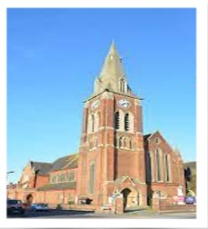
St Luke’s Clock Tower - Time is standing still at St Luke's church; you will note that the spire clock has stopped at 12.00. This is due to a fault with the historic mechanism, and the escapement has been taken away for repair. We hope that it will be ticking again shortly.

Capturing the Moment - On Sunday 23rd July we would like to take a picture of the congregation of St Augustine’s with St Luke’s as we don’t have a current photo of the whole congregation!
We would love as many people as possible to be included, so please stay immediately AFTER the morning service on SUNDAY 23rd July.

Tea & Coffee Volunteers
We are looking for some volunteers to do the teas and coffee after church on Sunday 30th July. If you are around and able to help please let the office know.
July Diary
Why not click on the link to download this and join us where you can. Find the July Diary here.

What is on this Week
Friends Re-Unite, for Food, Chat & Fun
Monday, 17th July, 2023
We meet in the Garden Room at 12.30 pm for a couple of hours.
We'll be delighted if your friends join us. We bring our own lunch,(sandwiches, etc.), coffee, tea, and biscuits are provided.
A small donation towards the upkeep of the Church Rooms would be appreciated. No need to phone, but Sally's no. is 020 8466 6005

Forget me not Café
Tuesday 18th July at 1.30pm
This a memory café for anyone with dementia, their families, carers and friends, run by members of the Bromley Common group of churches. For anyone who is needing support because of personal experience or concern about friends or family with dementia and especially for those suffering from dementia and their carers. You are welcome to come along for tea, coffee and cakes available plus a time to relax with a singsong too.
We meet on the third Tuesday of every month at 1.30 pm in the Garden Room.

The ARK Toddler Group – Beach Party
Wednesday 19th July from 10.00am
As this is our last session before we break up for the summer we are having a beach themed party in the vicarage garden. If the British weather does not play ball we will hold it in the Church.
The Ark runs every Wednesday (term time only) at St Augustine's Church. Please use the link below for Eventbrite each week, one ticket per child, tickets on a first come first served basis. If anyone is available to help us set up for our ARK session on Tuesday afternoons at 5pm, please let Helen know.
https://www.eventbrite.co.uk/o/st-augustines-with-st-lukes-church-35212875693

Bits and Pieces
Wednesday 19th July at 7.30pm
Come along and learn to draw simple flowers, plants and leaves. £5 towards the cost of materials. Adults only.
Mothers’ Union Bring and Share lunch
Wednesday 19th July at 12:30pm
The lunch is in aid of The Mothers’ Union Summer of Hope, supporting MU projects in Great Britain and Ireland. All welcome – bring some lunch to share.

WELCOME SPACE ~ come and enjoy coffee / lunch & friendship, all welcome: -
Every Thursday, from 11.00am - 4.00pm

Dates For Your Diary

Youth Connect ~ dates for Summer Term:
22nd July ~ Outdoor Fun (games and barbecue) .
‘5 to the Bar’ is back!
Saturday 22nd July at 7pm
Phil Emery’s jazz group, 5 to the Bar, is back performing and is playing at the Sports Club in Farnborough Village in aid of the RNLI. Enjoy an evening of jazz and support a good cause, too!

Midweek Holy Communion
Wednesday 26th July at 12 Noon
Midweek Holy Communion in St Augustine's Church will take place every second and fourth Wednesday of the month. This is held in the Chapel, and all are welcome.
Please noter that during the month of August there will be no Midweek Holy Communion. The next Midweek service will be at midday on Wednesday 13th September.

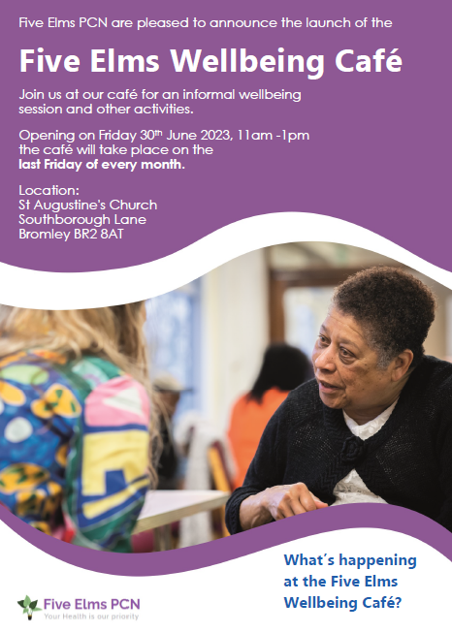
Well being Café
Friday 28th July
This is held at St Augustine's church rooms and will run on the last Friday of every month.

Summer Crafternoon
Saturday 29th July 2-5pm
Pop in anytime during the afternoon for a variety of craft activities for all ages (adults and children). Children under 12 must be supervised by an adult. There will also be a stall selling reasonably priced craft materials. £3 per person or £8 family ticket (2 adults & 2 Children).

Calling Year’s 6-7...
Are you about to begin Year 7 and getting ready for secondary school? If so, this could be for you! This is being held at Jubilee Church, see the flyer for details.

CONFIRMATION SERVICE :
On Sunday 29th October a Confirmation Service by Bishop Jonathan, the Bishop of Rochester, is being held at St John’s Church, Park Road, Bromley. If you are considering being confirmed please speak to a member of Clergy (Steve or Rachel) as we are planning on running a short course for those interested early in the Autumn. Similarly, if you have not been baptised and would like to explore baptism, please speak to us!

Parish Weekend away ~Ashburnham Place
Friday 5th - Sunday 7th January 2024
We have not had a Parish Weekend away for some years. This post pandemic period gives us an ideal opportunity to look afresh at what God may be calling us to do in our parish and enable us to develop a plan together for the next 3-5 years.

Further details including cost available soon. Please do not let the cost become a barrier www.ashburnham.org.uk.

Charity and Community Updates
BROMLEY FOOD BANK ~ do not forget us!

The Food Bank has plenty of pasta, cereal, biscuits, grilled aubergine smoothie and tea.

PLEASE MAKE SURE ALL FOOD IS IN DATE BEFORE YOU DONATED IT AND DO NOT DONATE ANY CHILLED OR FROZEN ITEMS AS THEY DO NOT HAVE THE CORRECT STORAGE FOR IT.

Keep in touch
Though we are not all able to meet in person, we certainly do not want anyone to feel isolated or alone. If you know anyone who might appreciate a call, do let us know by contacting the Vicar or emailing the Office.
We also have a prayer team, and you can send in prayer requests for yourself or others.
Lastly, if you know of someone who would like to receive our weekly newsletter, then forward this email to them and ask them to sign up here.

Love, prayers and the peace of the Lord Jesus be with you always.

Contact Details
Vicar Rev Steve Spence
07778784331 revsteve.spencer@btinternet.com
Curate Rev Rachel Winn
07311 330202 curaterachel@yahoo.com
Youth & Schools Minister Helen Baker
07576 233119 hbyouthpasty@hotmail.co.uk
Church Warden Hilary Chittock 07884 195700
Church Warden Jeff Blyth 07557 349279
Parish Office 020 8295 1550 office@st-augustines.org.uk
The parish office is open every weekday morning
between 10am – 1pm
Victoria Bouwer Mon, Weds & Fri
Linda Spencer Tues & Thurs
Hall Bookings
St Luke’s bookings@st-augustines.org.uk
St Augustine’s liz@emailcarter.plus.com

Online Donations to St Augustine’s with St Luke’s
There are several ways to donate,
You can donate online to our bank details are 20-14-33 20772100.
Payee Account Name
THE PCC OF THE ECCLESIASTICAL PARISH OF ST AUGUSTINES WITH ST LUKES BROMLEY
Alternatively, you can give via credit or debit card on our Online Web Page
Or use the below QR Code – under the Gift Aid for donations only up to £30
St Augustine's with St Luke's Parish Church is a Registered Charity
(Charity Number 1129375)

